**Build YourSelf: Streamlining Educational Growth**

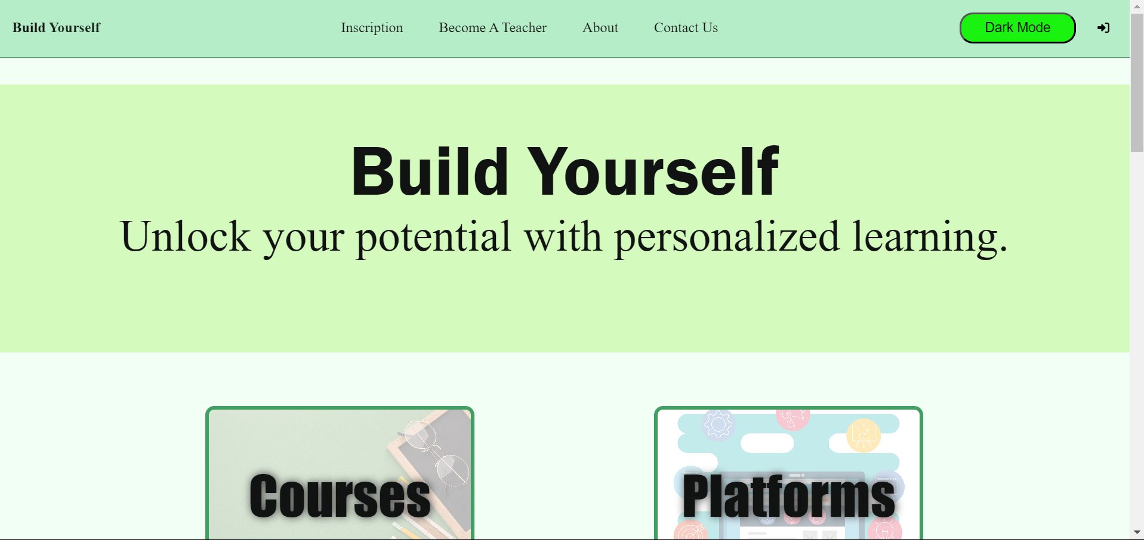**Purpose of the Project**

Our project, **Build YourSelf**, is an intuitive web application designed to streamline the registration and job application process for students and teachers at training centers. Our goal is to enhance the digital experience while fostering educational growth.

**Team Members and Roles**

Our team consists of Abdellah Boulidam and myself. We are both IT and DATA students, capable of working on both the frontend and the backend of the project.

In the initial stages of the project, we worked together to create a schema for the database using the Merise method. After finalizing the schema, we proceeded to create the database using SQL.

During the course of the project, we learned Express.js together and incorporated it into our application. For both the frontend and the backend, we combined our efforts to ensure a seamless integration of all components.

We believe that by working together on all aspects of the project, we were able to collaborate more effectively, exchange feedback, and learn from each other. We are confident that our combined skills and motivation led to the successful completion of the project.

Our project leverages several technologies like html, css, node js and smtp service…

**Target Audience**

Our project, Build YourSelf, was created with a focus on the educational sector. It serves three main groups:

Students: The application is designed to help students develop themselves in various fields. It provides a platform where they can easily register for courses, apply for jobs, and gain access to a wealth of educational resources.

Teachers: It also serves as a platform for teachers looking for employment opportunities. Teachers can register, create profiles, and apply for jobs at various training centers.

Training Centers: Finally, our project simplifies the process of student registration for training centers, making it easier for them to manage their operations.

By catering to these groups, our project aims to foster educational growth and streamline the digital experience in the educational sector.

**Challenge Statement**

Our main challenge was to create a user-friendly interface that would be both web and mobile-friendly, while also sourcing a reliable and sophisticated API. We focused on creating an experience that would be easy for both students and teachers to navigate, making the registration and job application process as seamless as possible.

Please note that the banner image is a placeholder as I’m unable to generate images. You can replace it with a screenshot or a logo of your application.

**Our Journey: From Desktop to Web**

Before we embarked on the Build YourSelf project, Abdellah Boulidam and I had previously worked on a desktop application using PyQt5. This application was designed for training centers, and it handled a variety of tasks such as registering students and proofs, managing courses, groups, and sessions, among other things.

Working on that project gave us a deep understanding of the challenges and needs of training centers. We saw firsthand how technology could simplify processes and enhance efficiency. However, we also realized that there was a need for a more user-centric solution - one that would allow users to register themselves and have more control over their educational journey.

This realization led us to the idea of Build YourSelf. We decided to continue in the same vein but shift our focus towards a web application. This would not only provide a more accessible platform for users but also allow us to leverage the power of modern web technologies to create a more robust and intuitive solution.

**Data Modeling :**

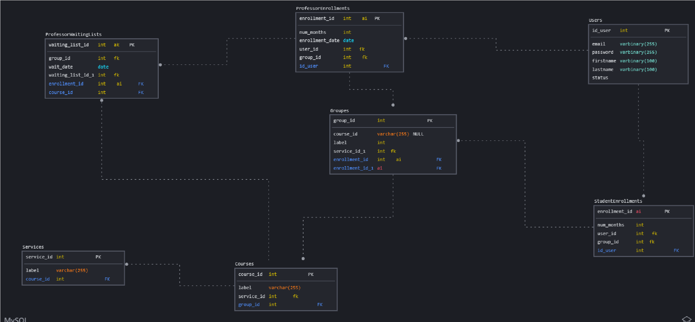

**Technologie used:**

HTML: We chose HTML as it is the standard markup language for creating web pages. It provided the structure of our application and is a fundamental technology we wanted to leverage.

CSS: We used CSS for styling the HTML elements. It enhanced the look and feel of our application, making it more user-friendly and visually appealing.

JavaScript (JS): We opted for JavaScript without any additional frameworks for the frontend. This decision was made to solidify our understanding of JavaScript and its core concepts. It also made our website interactive and is essential for client-side scripting.

Express.js: For the backend, we chose Express.js, a web application framework for Node.js. It allowed us to build our web application and APIs more efficiently and effectively.

MySQL: We used MySQL, a relational database management system, for storing and retrieving data. It was chosen for its reliability and wide usage in the industry.

Render: We used Render for hosting and serverless backend services for our web application. It allowed us to keep our site up-to-date directly from our repository.

SMTP Service: We integrated an SMTP Service for sending emails. This feature is crucial for various purposes such as sending registration confirmations, password resets, notifications, and more to our users.

In the development of Build YourSelf, we made a conscious decision to work without using any CSS framework. This was done to give us more hands-on experience and practice with CSS, allowing us to better understand and apply its principles.

For the backend, we chose to use Express.js over Flask, despite having prior experience with Flask. The reason behind this choice was our desire to learn and grow.

**Features:**

Responsive Design: Our application is designed to be responsive and compatible with mobile and tablet views. This means users can access the project from any device, providing flexibility and convenience.User-Friendly Interface with Dark Mode: We’ve focused on creating a user-friendly interface that includes a dark mode. This not only enhances the visual appeal of our application but also provides a comfortable viewing experience for users, especially in low-light conditions.

Easy Account Creation: We’ve streamlined the account creation process, making it easy for users to create accounts. This simplifies the registration process and allows users to quickly access the features and resources available on our platform.

### Technical challenge(STAR Method) :

Situation: In the early stages of our project, we faced a significant challenge in understanding the concepts of Express.js. This was crucial as our application had a backend and we needed to ensure it was robust and efficient.

Task: Our task was to gain a comprehensive understanding of Express.js to effectively use it in our project. We also needed to find a reliable and free service for deploying our application and setting up a cloud database. Additionally, we aimed to make our application responsive across all screens and implement an SMTP service for email verifications.

Action: We began by extensively researching Express.js, watching numerous videos, and studying various materials to grasp its concepts. For deployment, we tested several platforms like Render, Netlify, and Vercel before settling on a suitable one. We found freesqldatabase.com, which offered us a free cloud database. To make our application responsive, we experimented with different CSS techniques until we achieved the desired result. For the SMTP service, we researched how to implement it with Gmail using JavaScript.

Result: After much effort and teamwork, we successfully understood and implemented Express.js in our project. We managed to deploy our application and set up a cloud database. Our application became responsive across all screens, and we successfully integrated the SMTP service for email verifications. Despite the small problems we encountered along the way, we resolved them through persistent research and discovery.

**What I‘ve learned**

Technical Takeaways: This project was my first web application with both frontend and backend, which provided me with a great opportunity to apply and reinforce my knowledge. I learned new technologies such as Express.js, which broadened my skill set. I also got the chance to practice the Merise method for conception and SQL queries, which deepened my understanding of database design and manipulation. Furthermore, I learned more about the SMTP protocol and its implementation in cases like ours.

Working as a Team: This project taught me the importance of teamwork and planning. Even though I had other studies, I learned to manage my time effectively to contribute to the project. Working as a team allowed us to collaborate, exchange ideas, and learn from each other, which enriched our overall learning experience.

Problem-Solving Skills: One of the most important lessons I learned from this project is that any problem can be resolved with patience and research. There were challenges along the way, but by staying patient, doing thorough research, and persisting, we were able to overcome them.

Future Engineering Path: This project has informed my engineering path by showing me the practical applications of what I’ve learned. It has also sparked my interest in exploring other areas of web development. I’m excited about the future projects I’ll undertake and the new things I’ll learn.

Beliefs Confirmation: Prior to this project, I believed in the power of continuous learning and problem-solving. This project confirmed these beliefs. It showed me that with continuous learning, collaboration, and problem-solving, we can create something valuable and impactful.

**Future Steps**

As a part of my continuous learning journey and commitment to improving Build YourSelf, I plan to recreate the website using different technologies in the future. This includes exploring CSS frameworks like Tailwind or Bootstrap to enhance the design and user interface of the application.

In addition, I’m also interested in diving into PHP frameworks such as Laravel for backend development. This will not only allow me to learn and apply a new programming language but also provide an opportunity to compare and contrast different technologies.

By recreating the website with these different technologies, I aim to broaden my skill set, gain new insights, and further improve the functionality and user experience of Build YourSelf. This aligns with my goal of continuous growth and improvement as a IT engineer.

**Conclusion:**

**I am Youness Boumlik, a passionate IT and DATA engineer student, always eager to learn and apply new technologies. This project, Build YourSelf, was particularly important to me as it was my first web application with both frontend and backend. It provided me with a great opportunity to apply what I’ve learned and also to learn new things. It was not just about building an application, but also about building my skills, knowledge, and confidence as an engineer. This project has significantly contributed to my journey in the field of web development.**

Linkedin Profile : [Youness Boumlik | LinkedIn](https://www.linkedin.com/in/youness-boumlik-a13935190/)

Github Profile : [Younessboumlik (Youness Boumlik) (github.com)](https://github.com/Younessboumlik)

Project Link : [Younessboumlik/Portfolio (github.com)](https://github.com/Younessboumlik/Portfolio)